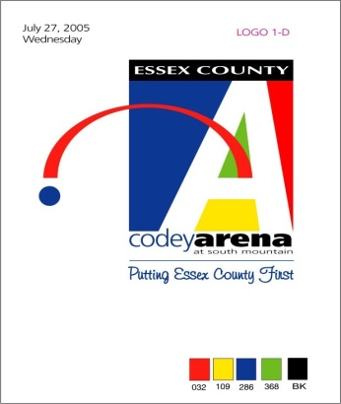**5 Reasons to Sign Your Kid up for Ice Skating Lessons…**

Ice skating is a timeless way to spend the winter months. But beyond the thrill of soaring across the ice, lessons are uniquely valuable experiences for kids and adults alike.

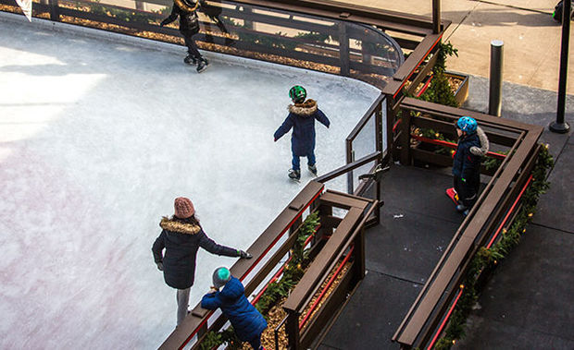

Ice skating lessons are increasing in popularity year after year, and parents across the country are praising the physical, emotional and social benefits of participating in the most popular winter sport. Plus, it’s fun. Really fun! Imagine your child hard at work with a big smile on their face. That’s the magic of ice skating.

With winter weather right around the corner, now is the perfect time to break out the skates and hit the ice. Need more convincing? Here are five reasons why you should stop what you’re doing and enroll your child in ice skating lessons.

**1. Gain valuable life lessons**

When young skaters skid onto the ice for the first time, they are learning so much more than how to skate: They are learning valuable life lessons that they can take with them into adulthood. On the outside, children are learning how to skate forward, skate backward, stop and turn, but with each new skill they master comes an underlying lesson in goal-setting, self-discipline and tenacity.

The first thing new skaters learn when entering the rink is how to fall and get up again. While this may seem like a no-brainer, giving them the power to decide to get up and try again is a powerful tool in developing self-confidence.

**2. Learn to fly**

Nothing compares to the feeling of gliding. Learning to glide is a skill that your child will remember forever. Many liken the experience to flying.

When asked how ice skating makes her feel, Nora of Richmond, Virginia, said, “I feel the wind rushing through my hair, and I feel free and happy.”

**3. Develop social skills**

The group lesson environment allows skaters to make new friends and develop relationships with peers at the same stage in their ice skating journeys.

Many elite skaters remain close friends with peers from their skating classes, citing the relationships they had at the rink as a catalyst to their success.

**4. Improve fitness**

While skating is great for cardiovascular fitness, the balance and control needed to master basic skating skills also builds muscle strength and improves coordination. Plus, with the average skate blade being a little more than 2 millimeters thick, skating is ideal for developing core strength and improving body awareness.

**5. Make memories as a family**

Skating lessons aren’t just for kids. In fact, many skating programs offer lessons designed specifically for adults. Pair a few simple tips with the right techniques and you’ll be on your own in no time. Imagine the memories you can make as a family, flying across the ice in your own winter wonderland!

Learn to Skate USA is the largest learn-to-skate program in the country, offering top-quality skating lessons at over 1,000 locations nationwide. With a standardized curriculum taught by certified Learn to Skate USA instructors, you can register for lessons with confidence knowing that your child will learn how to ice skate in a fun, safe and educational environment.

Once your child masters the fundamentals of skating, they will be equipped with the skills, knowledge and strength needed to move on to more specialized skating classes including hockey, speedskating, free skate, Theatre On Ice and more!

*Sincerely,*

***Stephen Ruggiero, Arena Director Anna Serpa, Arena Manager***

*sruggiero@parks.essexcountynj.org aserpa@parks.essexcountynj.org*

*973.731.3828 ext. 229 973.731.3828 ext. 225*

***Rachel Gomez-Bulmer, Learn to Skate Coordinator***

*rgomez@parks.essexcounty.nj.org*

*973.731.3828 ext. 223*

***Essex County Codey Arena***

*South Mountain Recreation Complex*

*560 Northfield Avenue*

*West Orange, NJ  07052*