Joseph N



**COUNTY OF ESSEX**

Department of Parks, Recreation and Cultural Affairs

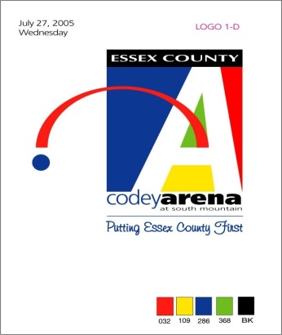

**Stephen M. Ruggiero**

**Arena Director**

# **ESSEX COUNTY CODEY ARENA**

**2022 ARENA FEE RATES**

**ICE RENTAL RATES**

**Private Ice Time Rate (Sept-June) $450 hour**

**Private Ice Time Rate (July-August) $350 hour**

**PUBLIC SESSION RATES (**Group Discount for 15 skaters or more ~ $1.00 off admission & rental)**

**Adult - $9 (*16 & older) Child - $7 (*15 & under) Senior - $7 (*Senior 62+)**

**Skate Rentals - $5**

**SKATING DISCOUNT CARDS**

**FREESTYLE Discount Pink Card $170 (**12 sessions for the cost of 10)**

* **Freestyle Session (1 hour) $17**
* **Freestyle Session (45 min) $13**

**ADULT Discount Gold Public Session Card $90 (**12 sessions for the cost of 10)**

**CHILD/SENIOR 62+ Silver Public Session $70 (**12 sessions for the cost of 10)**

**SKATE RENTAL Card $50 (**10 skate rentals)**

**HOCKEY**

**HIGH SCHOOL HOCKEY GAME Discount Card**

**$60 Adults / $40 Students & Seniors 62+ (**12 games for the cost of 10)**

**PRIVATE HOCKEY SESSIONS**

* **Hockey Session $20 player**
* **Hockey Coach $20 coach**

**ADULT STICK N’ PUCK $20 skater (goalies free)**

**FAMILY STICK N’ PUCK $20 skater**

